* **You have 1 GitHub repository with 3 branches- (Eg: 2025Q1, 2025Q2, 2025Q3). Each branch has its own individual index.html file.**

**We have 3 slaves, Now let’s create a Jenkins pipeline job and deploy index.html inside respective slave (Eg: index.html of 2025Q1 branch be deployed on slave1 and so on…)**

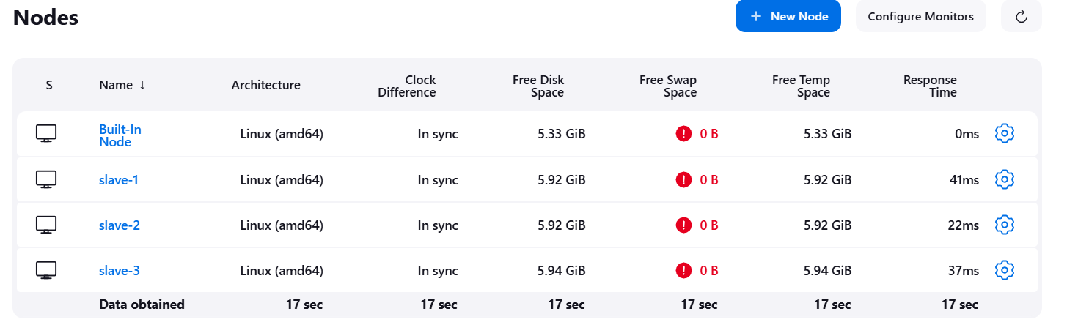

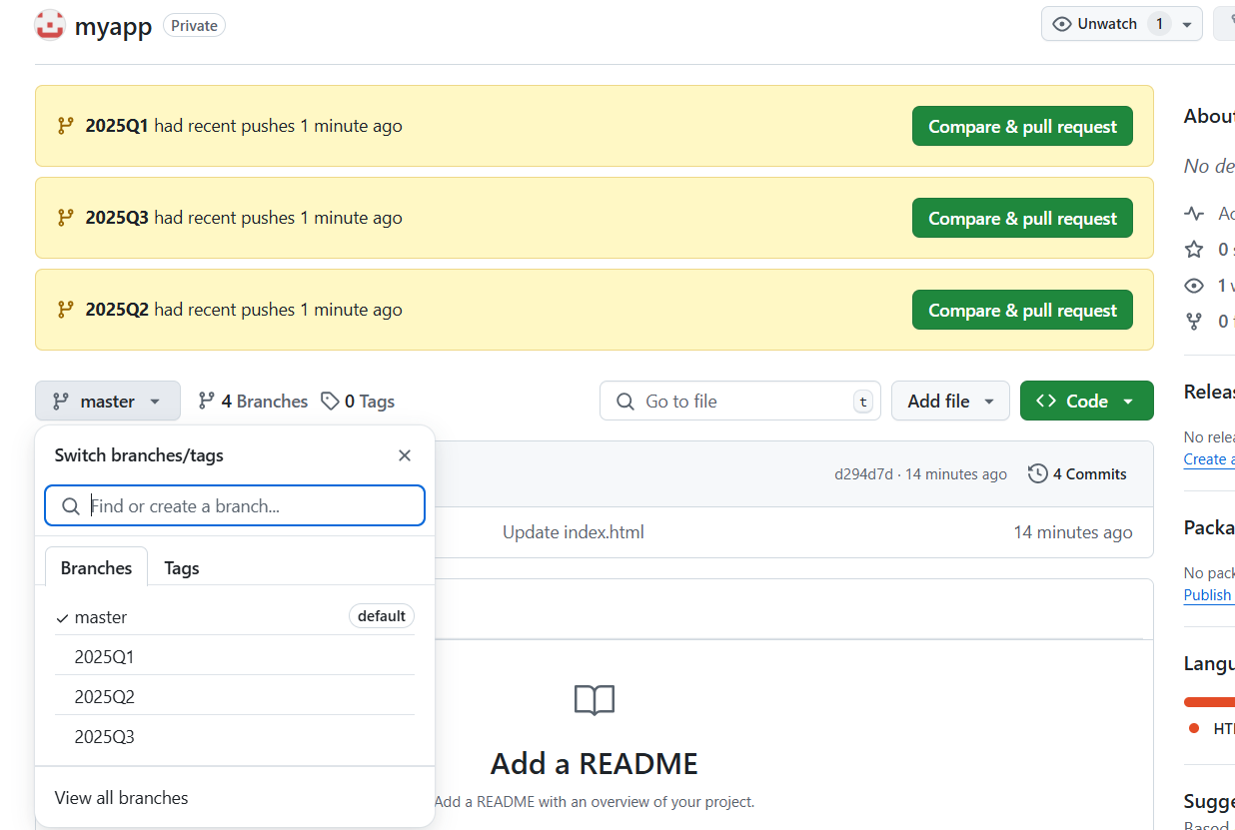

**// Clone repo from multiple-branch and deploy index.html:**

**pipeline{**

**agent{**

**label{**

**label "dev"**

**}**

**}**

**stages{**

**stage("deploy-slave-1"){**

**steps{**

**git branch: '2025Q1', credentialsId: 'git-token', url: 'https://github.com/om123122/myapp.git'**

**sh ''' sudo chmod -R 777 /var/www/html/**

**cp index.html /var/www/html/ '''**

**sleep 10**

**}**

**}**

**stage("deploy-slave-2"){**

**agent{**

**label{**

**label "qa"**

**}**

**}**

**steps{**

**git branch: '2025Q2', credentialsId: 'git-token', url: 'https://github.com/om123122/myapp.git'**

**sh ''' sudo chmod -R 777 /var/www/html/**

**cp index.html /var/www/html/ '''**

**sleep 10**

**}**

**}**

**stage("deploy-slave-3"){**

**agent{**

**label{**

**label "uat"**

**}**

**}**

**steps{**

**git branch: '2025Q3', credentialsId: 'git-token', url: 'https://github.com/om123122/myapp.git'**

**sh ''' sudo chmod -R 777 /var/www/html/**

**cp index.html /var/www/html/ '''**

**sleep 10**

**}**

**}**

**}**

**}**

**Output –**

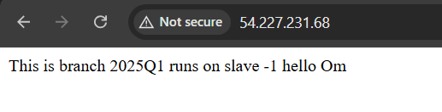

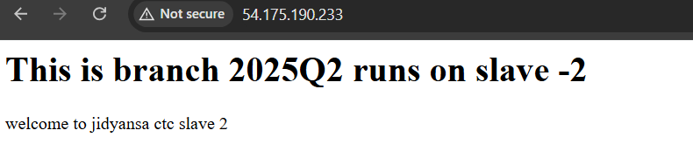

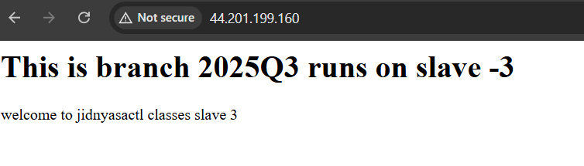

* **You have to create scripted pipeline for LoginWebApp practical, On 2 slave mahines.**

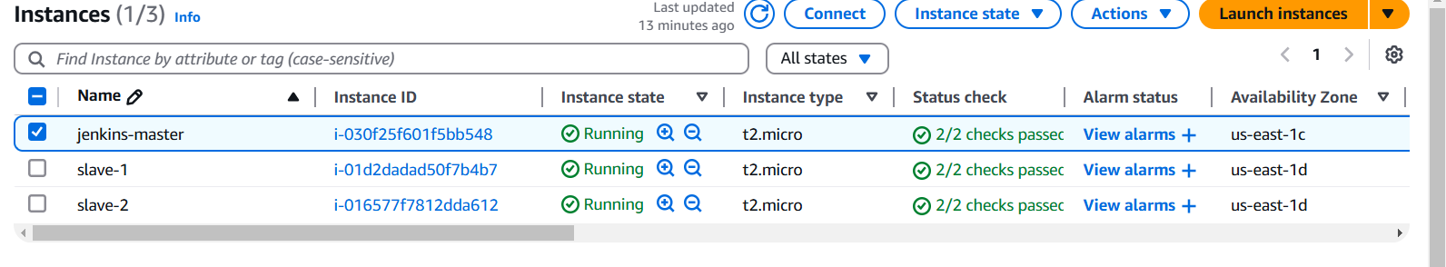

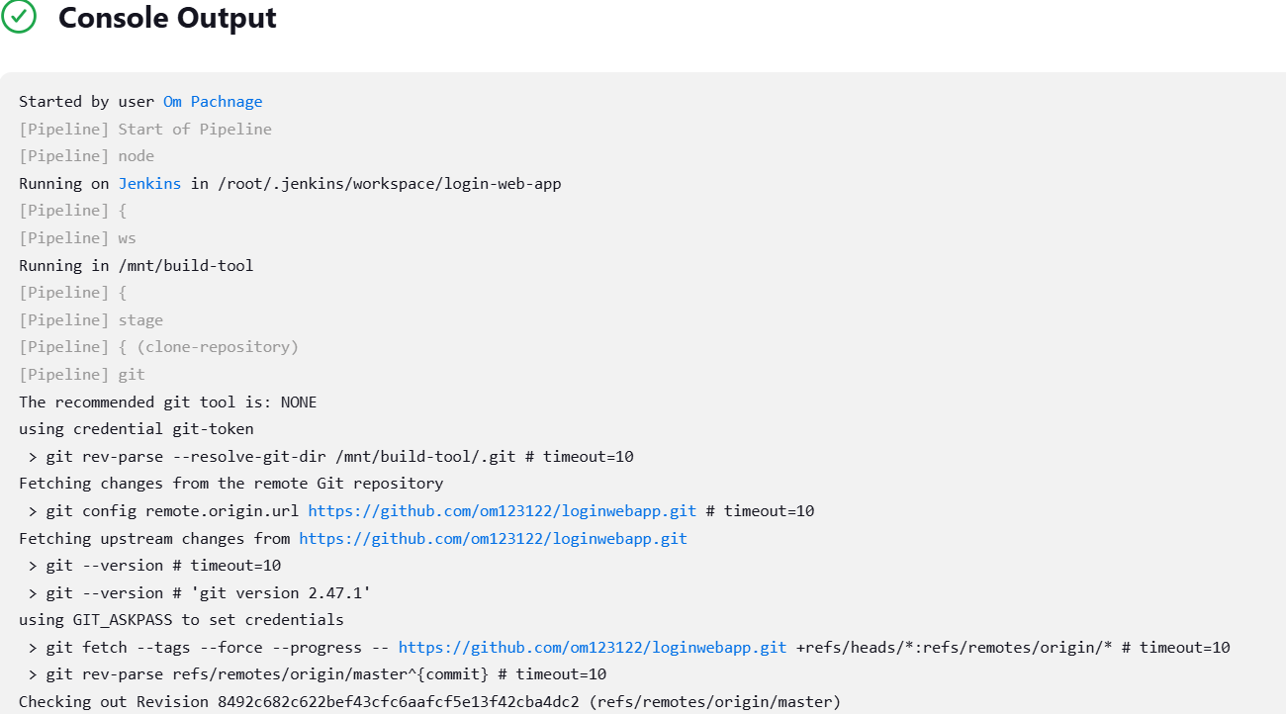

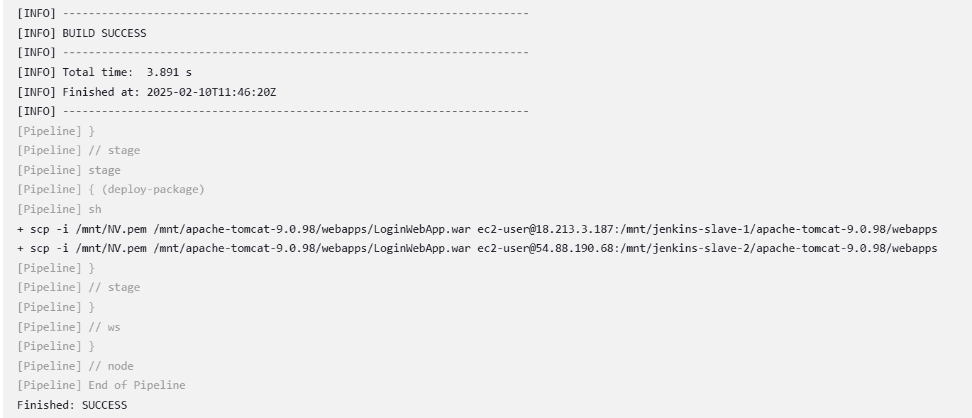

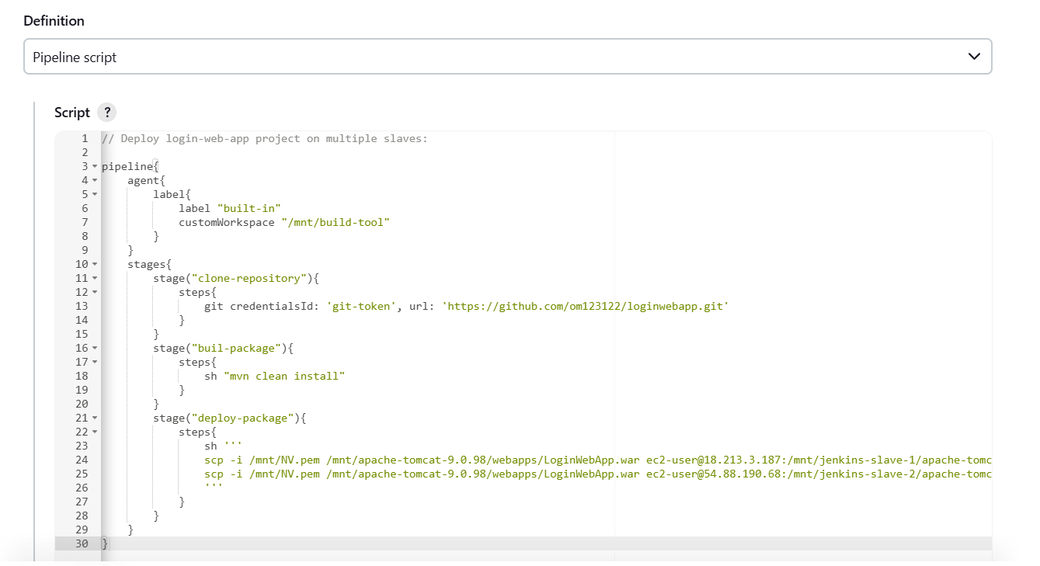

**Output –**

**Jenkins master**



**Slave-1**

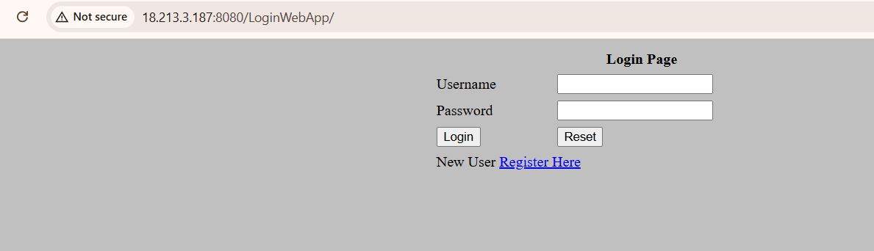

**Slave -2**

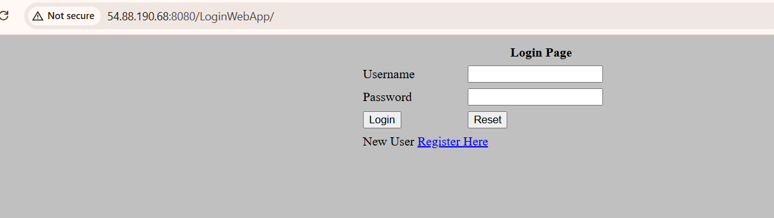

* **Write a Jenkinsfile to create parameter to accept password from user and then check if password is 'Admin@123' if correct then run the Job else exit the Job with message 'Password is incorrect exiting the Job'**

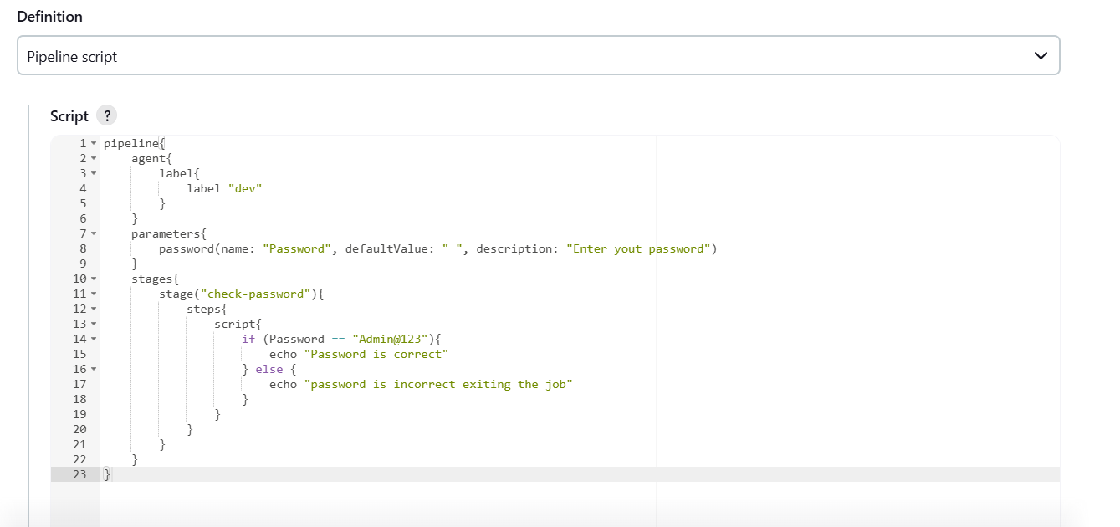

**Used Password parameter**

**Output –**

